Buatlah aplikasi dengan beberapa syarat sebagai berikut :

1. Memiliki login, dimana menggunakan shared prefereces untuk menyimpan data login (seperti session pada php)

~~2. Memiliki~~**~~minimal 2~~****~~fragment pada botom navigation~~**

~~3. Memiliki~~**~~minimal 1 recycler view~~**

Halaman Login xml

*<?*xml version="1.0" encoding="utf-8"*?>*<LinearLayout xmlns:android="http://schemas.android.com/apk/res/android"  
 xmlns:app="http://schemas.android.com/apk/res-auto"  
 xmlns:tools="http://schemas.android.com/tools"  
 android:layout_width="match_parent"  
 android:layout_height="match_parent"  
 android:orientation="vertical">  
  
 <EditText  
 android:id="@+id/userName"  
 android:layout_width="370dp"  
 android:layout_height="wrap_content"  
 android:layout_marginLeft="16dp"  
 android:layout_marginTop="32dp"  
 android:layout_marginRight="16dp"  
 android:ems="10"  
 android:hint="Username.."  
 app:layout_constraintHorizontal_bias="0.0"  
 app:layout_constraintLeft_toLeftOf="parent"  
 app:layout_constraintRight_toRightOf="parent"  
 app:layout_constraintTop_toTopOf="parent" />  
  
 <EditText  
 android:id="@+id/passWord"  
 android:layout_width="370dp"  
 android:layout_height="wrap_content"  
 android:layout_marginLeft="16dp"  
 android:layout_marginTop="16dp"  
 android:layout_marginRight="16dp"  
 android:ems="10"  
 android:hint="Password.."  
 app:layout_constraintLeft_toLeftOf="parent"  
 app:layout_constraintRight_toRightOf="parent"  
 app:layout_constraintTop_toBottomOf="@+id/userName" />  
  
 <Button  
 android:id="@+id/loginAkun"  
 android:layout_width="225dp"  
 android:layout_height="wrap_content"  
 android:layout_marginLeft="100dp"  
 android:layout_marginTop="8dp"  
 android:layout_marginRight="16dp"  
 android:onClick="loginAkun"  
 android:text="LOGIN"  
 app:layout_constraintHorizontal_bias="0.0"  
 app:layout_constraintLeft_toLeftOf="parent"  
 app:layout_constraintRight_toRightOf="parent"  
 app:layout_constraintTop_toBottomOf="@+id/passWord" />  
  
 <Button  
 android:id="@+id/clear"  
 android:layout_width="225dp"  
 android:layout_height="wrap_content"  
 android:layout_marginLeft="100dp"  
 android:layout_marginTop="16dp"  
 android:layout_marginRight="16dp"  
 android:layout_marginBottom="8dp"  
 android:onClick="clearKolom"  
 android:text="CLEAR "  
 app:layout_constraintBottom_toBottomOf="parent"  
 app:layout_constraintHorizontal_bias="0.0"  
 app:layout_constraintLeft_toLeftOf="parent"  
 app:layout_constraintRight_toRightOf="parent"  
 app:layout_constraintTop_toBottomOf="@+id/loginAkun"  
 app:layout_constraintVertical_bias="0.043" />  
  
</LinearLayout>

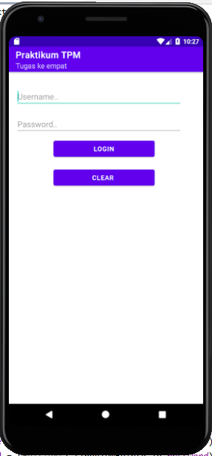 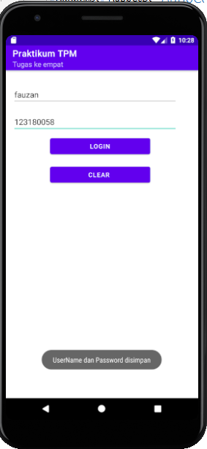 

Halaman login java

package com.praktikum.tugasempat;  
  
import androidx.appcompat.app.AppCompatActivity;  
import android.content.Context;  
import android.content.SharedPreferences;  
import android.os.Bundle;  
import android.view.View;  
import android.widget.EditText;  
import android.widget.Toast;  
  
public class MainActivity extends AppCompatActivity {  
  
 EditText userName, passWord;  
 SharedPreferences preferences;  
 public static final String *KEYPREF* = "Key Preferences";  
 public static final String *KEYUSERNAME* = "Key Username";  
 public static final String *KEYPASSWORD* = "Key Password";  
 *//deklarasi editext ,sharedpreferences ,dan Key* @Override  
 protected void onCreate(Bundle savedInstanceState) {  
 super.onCreate(savedInstanceState);  
 setContentView(R.layout.*activity_main*);  
  
  
 getSupportActionBar().setTitle("Praktikum TPM");  
 getSupportActionBar().setSubtitle("Tugas ke empat");  
  
 userName = (EditText) findViewById(R.id.*userName*);  
 passWord = (EditText) findViewById(R.id.*passWord*);  
 *//instansiasi editext* preferences = getSharedPreferences(*KEYPREF*, Context.*MODE_PRIVATE*);  
  
 *//instansiasi preferences* if (preferences.contains(*KEYUSERNAME*) && (preferences.contains(*KEYPASSWORD*))) {  
 userName.setText(preferences.getString(*KEYUSERNAME*, ""));  
 passWord.setText(preferences.getString(*KEYPASSWORD*, ""));  
  
 }  
 *//kondisi jika aplikasi di buka kembali ,maka akan menyimpan data dari sharedpreferences  
 //berdasarkan Key* }  
  
 public void loginAkun(View view) {  
 String user = userName.getText().toString();  
 String pass = passWord.getText().toString();  
 SharedPreferences.Editor editor = preferences.edit();  
 editor.putString(*KEYUSERNAME*, user);  
 editor.putString(*KEYPASSWORD*, pass);  
 editor.apply();  
 Toast.*makeText*(this, "UserName dan Password disimpan", Toast.*LENGTH_SHORT*).show();  
 *//menyimpan data user dan pass  
 //dengan method appley* }  
  
 public void clearKolom(View view) {  
  
 userName.setText("");  
 passWord.setText("");  
  
 *//hanya bertugas mengkosongkan kolom, bukan menghapus data dari SharedPreferences* }  
  
  
}